TITLE (Times New Roman 14, centered)

Authors (Times New Roman 12). Corresponding author underlined.

ª Affiliation (Times New Roman 10). E-mails of all co-authors should be included

^{b}

^{c}

INTRODUCTION
The main objectives, results and conclusions of the work to be presented on the BIOPOL-2022 Conference which will be published on the conference abstract book. The abstract should not exceed one A4 page, with the superior and inferior margins must have 30 mm and the left and right margins 25 mm.
The title of the abstract must be related to the contribution that will be presented (Times New Roman, 14 pts. Bold, centered), followed by the authors names (Times New Roman, 12 pts, centered, with the name of the presenting author underlined) and their affiliation (10 pts, centered).
The text must be written on a single column on Times New Roman, 11 pts.
The Introduction section should briefly present the work where objectives should be listed and bibliographical references related to the subject should be introduced in the text in straight brackets [1-3] being referred on the last section of this abstract.

EXPERIMENTAL
If necessary, there will be a section dedicated to the materials and methods that should be briefly described.

RESULTS AND DISCUSSION
Results should be presented and discussed including, if necessary, tables and figures. Tables will be referred on the text through a roman number: Table I ((Times New Roman, 10 pts, centered). Figures should be referred adding the word Figure to its order number: Figure 1 (Times New Roman, 10 pts, centered).

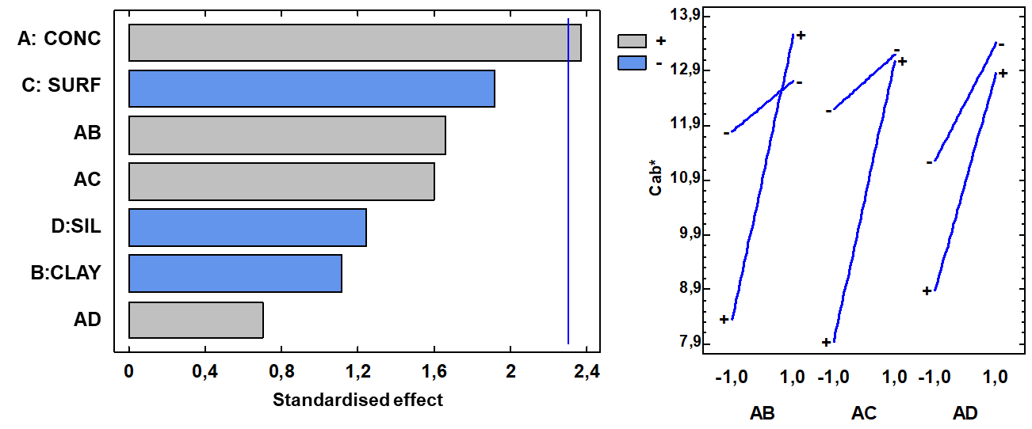
Figure 1. Example of an image inserted on the text

CONCLUSIONS
The most relevant contributions of the study should be summarized in this section.

REFERENCES
1. Pelegrín, C. Ramos, M., Jiménez, A. Garrigós, M.C. Frontiers in Nutrition. 2022, 9, 944830.
2. Dean, W.E. “Machining”, Marcel Dekker, New York, 1998.

