UNIT 17
01-P-G-VPGERUND
01.- VERB PATTERNS: VERBS IN -ING AFTER PREPOSTIONS.
We always use the -ing form of the verbs after prepositions.
Ex: I’m very bad at playing tennis.
Ex: Jenny is interested in learning new languages.

02-A-G-VPGERUND
02.- COMPLETE THE SENTENCES WITH THE -ING FORM OF THE VERB IN BRACKETS.

1.- I’m not very keen on men __________ (talk) about football in bars.
2.- I’m looking forward to __________ (travel) to Norway next Easter vacation.
3.- My dad is afraid of __________ (fly). He has aerophobia.
4.- My youngest brother is not very good at __________ (make) friends. He’s extremely shy!
5.- We’re looking forward to (meet) __________ them.
KEY: 1.- talking 2.- travelling 3.- flying 4.- making 5.- meeting

03-A-G-VPGERUND
03.- VERB PATTERNS: VERBS IN -ING AFTER OTHER VERBS.
We use verbs in -ing after the following verbs:
can’t stand | enjoy | finish | go | hear | imagine | mind | see
Ex: I can’t stand people talking about football.
Ex: I always go cycling at the weekend.
04-A-G-VPGERUND
04.- VERB PATTERNS: VERBS IN -ING AFTER OTHER VERBS.
1.- Would you mind __________ (open) the window? It’s a bit hot here!
2.- I’ve just finished __________ (iron) my clothes.
3.- I don’t enjoy __________ (do) the washing up at all.
4.- My cousin Dawn usually goes __________ (snowboard) in the winter holidays.
5.- I can’t imagine my life __________ (be) different to what it is now.
KEY: 1.- opening 2.- ironing 3.- doing 4.- snowboarding 5.- being
05-A-G-VPGERUND
05.- VERB PATTERNS: VERBS IN -ING AFTER OTHER VERBS.
1.- What sport does your husband enjoy __________(play)?
2.- I can’t stand __________ (get) early in the morning.
3.- Be quiet! I can hear someone __________ (open) the main door. They might be burglars!
4.- I’ve just seen Martha __________ (kiss) a man who isn’t her boyfriend!
5.- I want to go __________ (shop) this afternoon. Would you come with me?
KEY: 1.- playing 2.- getting 3.- opening 4.- kissing 5.- shopping

06-P-G-VPINF
06.- VERB PATTERNS: VERBS IN INFINITIVE AFTER ADJECTIVES.
After most adjectives we always use infinitive form of the verbs.
Ex: It’s impossible to finish the essay on time.
Ex: I’m very happy to see you here.

07-A-G-VPINF
07.- COMPLETE THE SENTENCES WITH THE INFINITIVE OF THE VERB IN BRACKETS.
1.- It’s not possible __________ (visit) the mansion today.
2.- Darlene was very exited __________ (know) about our holiday in the Bahamas.
3.- I was very pleased __________ (receive) the email from her new company.
4.- We were so delighted __________ (see) our elder son in Dublin!
KEY: 1.- to visit 2.- to know 3.- to receive 4.- to see

08-P-G-VPINF
08.- VERB PATTERNS: VERBS IN INFINITIVE AFTER OTHER VERBS.
We use verbs in the infinitive after the following verbs:
AFFORD | AGREE | CHOOSE | DECIDE | EXPECT | WOULD PREFER | MANAGE | WOULD LOVE
OFFER | PLAN | PROMISE | WANT | HOPE | WOULD LIKE | LEARN | WOULD HATE
Ex: I can’t afford to buy a new car.
Ex: When I was a child I wanted to become a doctor.
09-A-G-VPINF
09.- VERB PATTERNS: VERBS IN INFINITIVE AFTER OTHER VERBS.
1.- Carla’s decided __________ (apply) for a new job in banking.
2.- Sam and Kris are hoping __________ (finish) their degree this year.
3.- I’d love __________ (travel) to New Zealand in the summer. It’ll be winter there!
4.- Gloria learned __________ (drive) in her late twenties.
5.- I chose __________ (study) Tourism at university because travelling is my favourite hobby.
KEY: 1.- to apply 2.- to finish 3.- to travel 4.- to drive 5.- to study

10-A-G-VPINF
10.- VERB PATTERNS: VERBS IN INFINITIVE AFTER OTHER VERBS.
1.- Jacky wants __________ (move) to Brazil by the end of the year.
2.- My uncle expects __________ (be) a millionaire very soon. He’s making a lot of money with his new startup.
3.- Dad, I promise __________ (study) harder for my final exams.
4.- Would you like __________ (come) to my party on Saturday?
5.- When I was living in the Netherlands I managed __________ (learn) Dutch.
KEY: 1.- to move 2.- to be 3.- to study 4.- to come 5.- to learn

11-P-G-VPSPECIAL
11.- VERB PATTERNS: SPECIAL CASES.
We use verbs in the gerund or the infinitive after the following verbs “start”, “begin”, “like”, “love”, and “hate”. There’s no difference in meaning.
Ex: I began studying / to study English when I was 10 years old.
Ex: I love travelling / to travel around Europe.

12-P-G- VPSPECIAL
12.- VERB PATTERNS: SPECIAL CASES.
We use verbs in the gerund or the infinitive after the following verbs “start”, “begin”, “like”, “love”, and “hate” with no change in meaning. The verbs “stop”, “remember”, and “forget” can be followed by gerund or infinitive, but the meaning will be different.
“stop” + gerund => when you’re doing an activity and don’t do it anymore
Ex: I stopped smoking when I got pregnant.
“stop” + infinitive => to express purpose
Ex: I was walking along the beach and stopped to lie down on the sand and sunbathe.
“remember” + gerund => when you remember that you did something in the past
Ex: I remember talking to my husband when we met for the first time in Paris.
“remember” + infinitive => when you have to remember to do something in the future
Ex: I must remember to call my dentist to get an appointment for next week.
“forget” + gerund => when you forget that you did something in the past
Ex: I’ve forgotten talking to my husband when we met for the first time in Paris.
“forget” + infinitive => when you forget to do something in the future
Ex: Don’t forget to feed the cat before you leave the home.

13-A-G- VPSPECIAL
13.- SPECIAL CASES. COMPLETE THE FOLLOWING SENTENCES WITH THE CORRECT FORM OF THE VERB (INFINITIVE AND/OR GERUND).
1.- Jenny began __________ (learn) French when she visited Paris two years ago.
2.- My friends and I like __________ (go) shopping on Saturday. We always spend a lot of money.
3.- Don’t forget __________ (post) those letters today, please. They’re really urgent!
4.- My children will always remember __________ (visit) Legoland. They had a great time there!
5.- Susan hates __________ (do) the housework. She has hired a cleaning lady.
KEY: 1.- learning / to learn 2.- going / to go 3.- to post
4.- visiting 5.- doing / to do

14-A-G-VPSPECIAL
14.- SPECIAL CASES. COMPLETE THE FOLLOWING SENTENCES WITH THE CORRECT FORM OF THE VERB (INFINITIVE OR GERUND).
1.- I will never forget __________ (meet) George Clooney in Los Angeles.
2.- We stopped at the supermarket __________ (get) some milk.
3.- My mother has stopped __________ (eat) meat because she’s become a vegetarian.
4.- The Smiths love __________ (travel) around Europe. They visit a different country every summer.
5.- Will you remember __________ (buy) me a magnet in Berlin. I collect magnets and I have over 100.
6.- Mandy has just started __________ (play) the piano. She wants to become a great pianist.
KEY: 1.- meeting 2.- to get 3.- eating
4.- travelling / to travel 5.- to buy 6.- playing / to play

15-A-R-VPATTERNS
15.- CORRECT THESE SENTENCES.
1.- I find it difficult getting up early at the weekend.
2.- They don’t mind to start work at 7:00 am.
3.- We’re thinking of to go to the theatre next Saturday.
4.- Jack goes cycle every evening after work.
5.- I’m looking forward to meet my new flatmate.
6.- Don’t forget writing when you’re in Brighton.
KEY:
1.- I find it difficult to get up early at the weekend.
2.- They don’t mind starting work at 7:00 am.
3.- We’re thinking of going to the theatre next Saturday.
4.- Jack goes cycling every evening after work.
5.- I’m looking forward to meeting my new flatmate.
6.- Don’t forget to write when you’re in Brighton.

16-A-R-VPATTERNS
16.- COMPLETE THE FOLLOWING TEXT WITH THE CORRECT FORM OF THE VERBS FROM THE BOX.
eat | do | travel | lose | take

learn | learn | eat | sightsee

Charles has a lot of plans. First, he wants (1) __________more German, so he’s going to study every day. He likes (2) __________ German, and at the end of the year he wants (3) __________ an official exam from the Goethe Institute.
He also wants (4) __________ more exercise, so he’s just taken up running. Also, he’s decided (5) __________ healthier. He’s going to stop (6) __________ sweet things and is going to eat more vegetables and fruit. He hopes (7) __________ at least 8 kilos before the summer.
He loves (8) __________ and enjoys (9) __________ in every city he visits. However, he needs to save up if he wants to travel this summer. He hopes to save €200 a month to be able to travel to China.
KEY: (1) to learn (2) learning / to learn (3) to take (4) to do (5) to eat
(6) eating (7) to lose (8) travelling / to travel (9) sightseeing

17-A-R-VPATTERNS
17.- COMPLETE THE FOLLOWING TEXT WITH THE CORRECT VERB IN THE GERUND OR INFINITIVE.

My sister Jacqueline and I are very different. She loves (1) __________ to music and I enjoy (2) __________ TV. She loves (3) __________ any kind of food and I don’t because I’m very bad at (4) __________. She’s really interested in (5) __________ French, but I can’t stand (6) __________ languages. I always forget (7) __________ my French homework, but she usually remembers (8) __________ it. I prefer music; I’m really good at (9) __________ the violin, and Jacqueline’s going to start (10) __________ the cello in a year or two.
KEY: 1.- listening / to listen 2.- watching 3.- cooking / to cook 4.- cooking
5.- learning 6.- learning 7.- to do 8.- to do 9.- playing 10.- playing/to play

18-A-L-VPATTERNS [WITH 1 AUDIO – 1 male]
18.- LISTEN TO THIS VOICE MESSAGE AND FILL IN THE GAPS WITH THE WORDS YOU HEAR.
Hey, Miranda! I’m so excited _______________ you that I’ve finally booked my flight to move to England. As you know, I decided _______________ abroad for some time because I need a change in my life and I think England is the perfect place for me - and you also live there! I can already imagine _______________ you for a drink and a chat or doing anything we plan _______________ because we always have lots of fun when we’re together.
We could do that whenever we have a bit of free time because I found a job near your flat. I’m quite afraid of _______________ something wrong because I’m the clumsiest person ever, you know that. But I’m really happy _______________ working there and face new challenges and meet new people.
I have to say good-bye now because it’s my mother’s birthday and I can’t forget to _______________ her. I’d love _______________ you as soon as I get there, so I’ll give you a call when the plane lands. Bye!
KEY:
Hey, Miranda! I’m so excited to tell you that I’ve finally booked my flight to move to England. As you know, I decided to live abroad for some time because I need a change in my life and I think England is the perfect place for me - and you also live there! I can already imagine meeting you for a drink and a chat or doing anything we plan to do because we always have lots of fun when we’re together.
We could do that whenever we have a bit of free time because I found a job near your flat. I’m quite afraid of doing something wrong because I’m the clumsiest person ever, you know that. But I’m really happy to start working there and face new challenges and meet new people.
I have to say good-bye now because it’s my mother’s birthday and I can’t forget to call her. I’d love to see you as soon as I get there, so I’ll give you a call when the plane lands. Bye!

19-A-L-VPATTERNS [WITH 1 AUDIO– 1 male]
19.- LISTEN TO THE VOICE MESSAGE AGAIN AND DECIDE IF THESE SENTENCES ARE TRUE (T) OR FALSE (F).

1.- The speaker wants to move to England because his life has changed. T / F
2.- He and Miranda have already plan a lot of things to do. T / F
3.- He will work near where Miranda lives. T / F
4.- He’s both scared and unhappy. T / F
5.- Miranda is picking him up from the airport. T / F
KEY: 1.- F 2.- F 3.- T 4.- F 5.- F

20-A-L-VPATTERNS [WITH 3 AUDIOS– 1 male, 2 females]
20.- LISTEN TO THE RECORDINGS AND MATCH THEM TO THESE QUESTIONS.
1.- Who forgot to do something? SARAH / LUKAS / TANIA
2.- Who has forgotten doing something? SARAH / LUKAS / TANIA
3.- Who stopped doing yoga? SARAH / LUKAS / TANIA
4.- Who stopped to do yoga? SARAH / LUKAS / TANIA
5.- Who likes riding horses? SARAH / LUKAS / TANIA
6.- Who would like to ride a horse? SARAH / LUKAS / TANIA
KEY: 1.- SARAH 2.- LUKAS 3.- SARAH
4.-TANIA 5.-LUKAS 6.-TANIA

21-A-L-VPATTERNS [WITH 1 AUDIO]
21.- LISTEN TO SARAH AGAIN AND CHOOSE THE CORRECT OPTION FOR EACH SENTENCE.
1.- It was her daughter’s first / last day of school.
2.- Sarah’s phone is never on vibrate / silent.
3.- Sarah’s daughter / teacher called her during her yoga class.
4.- Sarah had forgotten to pack her daughter’s bag / packed lunch.
KEY: 1.- first 2.- silent 3.- teacher 4.- packed lunch

22-A-V-TRANSPORT
22.- WRITE THE CORRECT WORD FROM THE CHART UNDER EACH PICTURE.
airplane | cruise | bus | car | bike


1.- ______________________ 2.-__________________
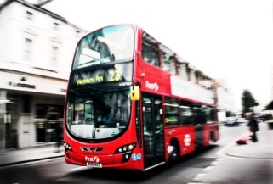
3.- ______________________ 4.- ______________________
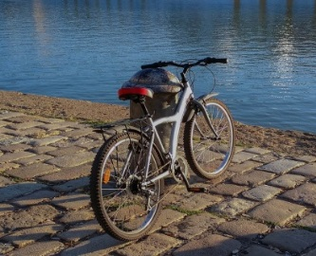
5.- _______________________
KEY: 1.- cruise 2.- airplane 3.- bus 4.- car 5.- bike

23-A-V-TRANSPORT
23.- WRITE THE CORRECT WORD FROM THE CHART UNDER EACH PICTURE.
helicopter | convertible | hot air balloon | moped | jeep

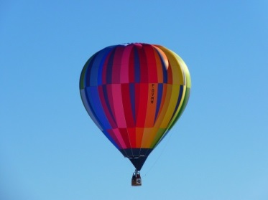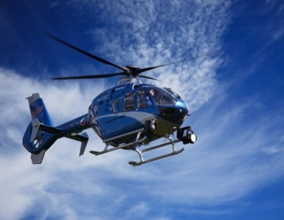
1.- ______________________ 2.-__________________
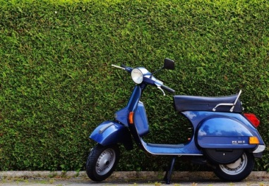
3.- ______________________ 4.- ______________________
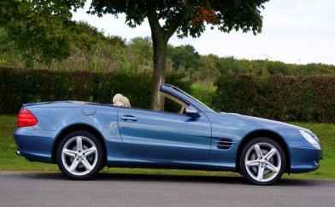
5.- ______________________
KEY: 1.- hot air balloon 2.- helicopter 3.- moped 4.- jeep 5.- convertible

24-A-V-TRANSPORT
24.- WRITE THE CORRECT WORD FROM THE CHART UNDER EACH PICTURE.
pickup truck | sailboat | van | taxi | tram


1.- ______________________ 2.-__________________
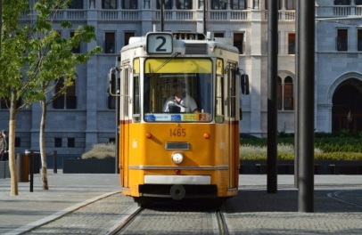
3.- ______________________ 4.- ______________________

5.- ______________________
KEY: 1.-taxi 2.-pickup truck 3.-tram 4.-sailboat 5.-van

25-P-V-TRAVELLING
25.- READ THE FOLLOWING RULES ON TRAVELLING PREPOSITIONS.
- From – To: We travel from our place to our destination.
Example: They travelled from Paris to London.
- Arrive at/in: We arrive in a country or town.
Example: We arrived in Germany last Monday.
We arrive in or at a village.
Example: We arrive at our small village yesterday.
We arrive at a small destination for example airport, station, hotel etc…
Example: We arrived at the hotel at midnight.
- Transport: by, get on, get out of, get off:
We travel by car, bus, plane, train and by air, sea etc…
Example: We travelled first by plane and then by car.
We get on a public vehicle, but we are in the/our car and you get into a car.
Example: I’m on the bus or I got on the train ten minutes ago. I’m in the/my car.
We get out of a private vehicle.
Example: Get out of the bus, get out of the car.
We get off a public vehicle.
Example: Let’s get off the bus at the next stop.

26-A-V-TRAVELLING
26.- CHOOSE THE CORRECT OPTION (A,B,C) TO FILL IN THE GAPS WITH THE CORRECT PREPOSITION.
1.- You get _________ a bus.
a) in b) on c) by
2.- You get _________ a car.
a) into b) on c) by
3.- You can go to the university _______ bike.
a) in b) on c) by
4.- We got _____ the bus at Oxford Street.
a) out of b) on c) off
5.- They arrived _____ Bournemouth last week.
a) to b) in c) from
KEY: 1.- b 2.-a 3.-c 4.-c 5.- b

27-A-V-TRAVELLING
27.- WRITE THE CORRECT PREPOSITION FROM THE CHART TO COMPLETE THE FOLLOWING SENTENCES.
by | off | into | out of | on

1.- She got _________ the car and drove home.
2.- Rachel is going to travel all the way to Italy ________ motorbike.
3.- They stopped and got _______ the car to have lunch in a fantastic restaurant.
4.- If we get _____ the bus at the next stop we will see the train station.
5.- I got ____ the tram and paid my ticket.
KEY: 1.- into 2.- by 3.-out of 4.-off 5.-on

28-A-V-TRAVELLING
28.- WRITE THE CORRECT PREPOSITION IN THE GAPS TO COMPLETE THE FOLLOWING SHORT PARAGRAPH.
We travelled (1)_______ Amsterdam (2)_______ Brussels (3)______ train. We arrived (4) _____ Brussels at 7:00 pm. When we got (5)_______ the train, our friend Marco was waiting for us outside the station so we got (6) ____ his car and we arrived (7)______ the hotel at 8:30 pm.
KEY: 1.- from 2.- to 3.- by 4.- in 5.- off 6.- into 7.- at

29-A-V-CITY&COUNTRY
29.- DRAG THE WORDS IN THE CHART TO THEIR CORRECT AREA TO FORM TWO LISTS OF WORDS BELONGING TO THE CITY OR TO THE COUNTRY.
farming | factory | parking lots | harvest | air pollution | hiking | skyscrapers | valleys

CITY COUNTRY
_____________________ ______________________
_____________________ ______________________
_____________________ ______________________
_____________________ ______________________
KEY: - City: factory, parking lots, air pollution, skyscrapers (in any order)
- Country: farming, harvest, hiking, valleys (in any order)

30-A-V-CITY&COUNTRY
30.- WRITE THE CORRECT WORD FROM THE CHART UNDER EACH PICTURE.
road | air pollution | highway | crowded | camping

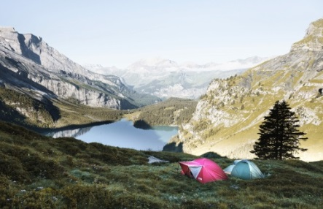
1.- ______________________ 2.-__________________

3.- ______________________ 4.-__________________

5.- ______________________
KEY: 1.- crowded 2.- camping 3.- road 4.- air pollution
5.- highway

31-A-V-CITY&COUNTRY
31.- WRITE THE CORRECT WORD FROM THE CHART TO COMPLETE THE FOLLOWING SENTENCES.
skyscrapers | clean air | road | hiking | crowded

1.- I love the country because there we can breathe _____________.
2.- I will always remember those spring days in my village when I was _______ with my father in the mountains.
3.- The city centre is very _________ now, it is full of people everywhere.
4.- On the way to the village we drove along a _______ full of trees.
5.- My city now has five ___________. They are huge buildings of about 40 floors.
KEY: 1.- clean air 2.- hiking 3.-crowded 4.-road 5.- skyscrapers

32-A-R-TRAVELLING
32.- READ THE FOLLOWING POSTCARD AND FILL IN THE GAPS WITH THE CORRECT ADJECTIVES FROM THE CHART.
luxurious | interesting | excellent | delicious | spectacular

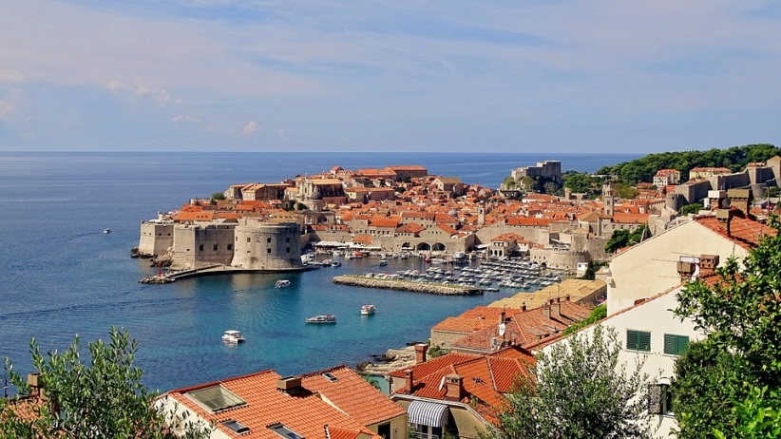
Dear Jane,
We arrived in Duvrovnik yesterday. Our journey was a little complicated because we had some problems with our flight, which was delayed, and we had to wait four endless hours. However, we are happy because we are in a fabulous city. We also have 1.- __________ weather and we are staying in a very 2.-________ hotel in a really beautiful beach. You can see in the picture the 3.______ views we can enjoy every day while we are having breakfast. This morning we did an 4.- _________ tour around the bay on board of a comfortable small boat. After that we went for a walk to the city centre to buy some souvenirs and tonight we are going to a very famous restaurant where the food is 5.-__________. I will tell you everything about our trip when I am back.
See you next week.
Best wishes,
Marthin.
KEY: 1.- excellent 2.- luxurious 3.- spectacular 4.- interesting 5.- delicious

33-A-R-TRAVELLING
33.- READ THE FOLLOWING POSTCARD AND FILL IN THE GAPS WITH THE CORRECT ADJECTIVES FROM THE CHART.
comfortable | cosy | great | relaxing | wonderful

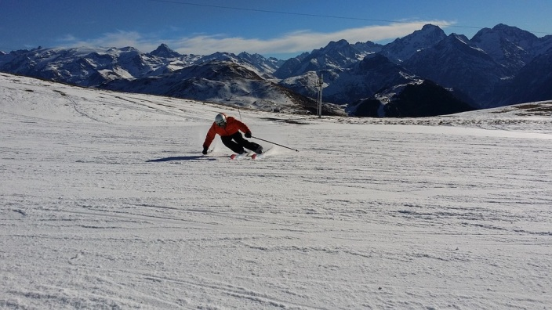
Dear Matha,
Here we are in the Alps having a 1.-_______ time. The weather is very nice and at night it’s snowing a lot, so this is perfect to ski and here you can find very well prepared cross country ski tracks and ski slopes, so you can do hard or just 2.-_______ exercise. We’re staying in very beautiful wooden cabins, which are well equipped and very 3.- _________. There are 4.-__________ views of the snow-covered mountains, as you can see in the picture. The food is delicious, especially the meat, and the desserts are very nice, too. We are really enjoying the stay. Yesterday we were skiing on many slopes all day until close to sunset. Then we went to the hotel to have a shower and get dressed to have dinner in the hotel restaurant next to a 5.- __________ fireplace. Tomorrow we are going to walk in the mountains to see wild animals and trees, and then we are going to the city centre to go shopping and to buy some souvenirs.
See you soon,
Paul.
KEY: 1.- great / wonderful 2.- relaxing 3.-comfortable
4.-wonderful /great 5.-cosy

34-A-R-TRAVELLING
34.- IMAGINE YOU ARE NOW ON HOLIDAY IN A BEAUTIFUL PLACE AND WRITE YOUR OWN POSTCARD TO AN ENGLISH FRIEND USING THE ADJECTIVES IN THE CHART.
great | exciting | amazing | delicious | wonderful

Dear_________
___________________________________________________________________________________________________________________________________________________________________________________________________________________________________________________________________________________________________________________________________.

35-A-L-TRAVELLING [WITH 1 AUDIO– 1 male]
35.- LISTEN TO MARK TALKING ABOUT TRAVELING AND WRITE TRUE (T) OR FALSE (F).
1.- Mark’s favourite holidays are in summer. T / F
2.- Mark loves travelling alone. T / F
3.- Last summer they went to Edinburgh. T / F
4.-They arrived at the hotel by taxi. T / F
5.- His wife loved the trip and wants to come back. T / F
KEY: 1.- T 2.-F 3.- F 4.- T 5.-F

36-A-L-TRAVELLING [WITH 1 AUDIO– 1 male]
36.- LISTEN TO MARK AGAIN AND CHOOSE THE CORRECT OPTION A OR B.
1.- Mark loves his summer holidays because…
a) he has two free weeks to relax. b) he can disconnect from work.
2.- They didn’t go to Edinburgh because…
a) it was more expensive. b) it was too cheap.
3.- We decided to take the bus because…
a) it was raining and they wanted to do a tour around the city.
b) it was raining and there were too many people in the taxi queue.
4.-They went to the hotel by taxi because…
a) they got out the bus in the wrong place. b) they wanted to live the experience.
5.- His wife didn’t enjoy the trip because…
a) she thinks everything was not very cheap. b) she thinks everything was very ugly.
KEY: 1.-b 2.-a 3.-b 4.-a 5.-a

37-A-L-TRAVELLING
37.- SPEAKING. FIND A PARTNER IN THE CHAT AND TALK ABOUT A BAD EXPERIENCE YOU HAVE HAD WHILE TRAVELLING. ANSWER THE FOLLOWING QUESTIONS.
1.- Where did you travel?
2.- How did you get there?
3.- Who did you go with?
4.- Where did you stay?
5.- What was wrong?
6.- How long did you stay there?
7.- Would you like to come back?

38-A-R-UK
38.- READ THE TEXT AND LOOK AT THE MAPS AND DECIDE IF THE SENTENCES ARE TRUE (T) OR FALSE (F).
Great Britain? United Kingdom? England?
Sometimes people use Great Britain, United Kingdom and England interchangeably. Here you have some descriptions and a map to help you make the difference.
UNITED KINGDOM GREAT BRITAIN
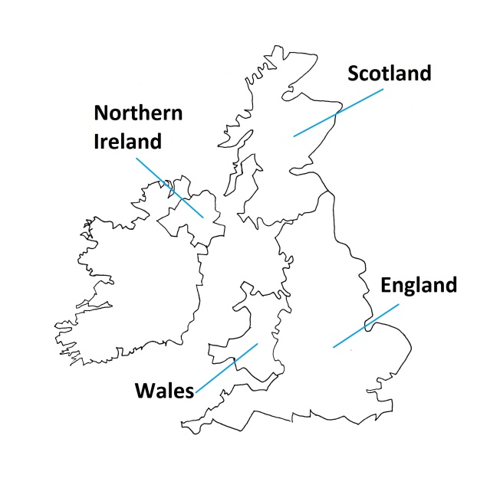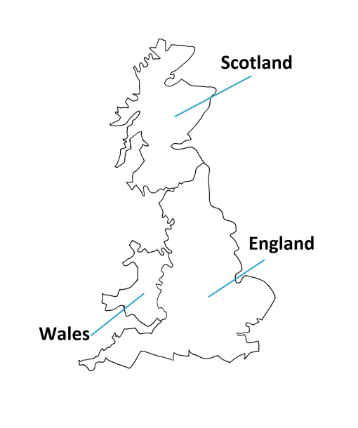
The United Kingdom is formed by England, Scotland, Wales, and Northern Ireland. However, Great Britain doesn’t include Northern Ireland.
England is the capital and the biggest country in the United Kingdom. Around 55 million people live there and its capital is London. Other important cities include Birmingham, Manchester, Liverpool, Leeds and Newcastle. Its official languages are English and Cornish.
Scotland is famous for its lakes and castles and it has over 5 million inhabitants. Its capital is Edinburgh and Glasgow, Aberdeen, Dundee and Inverness are important cities, too. Its official languages are English, Scots and Gaelic.
Wales is also known for its ancient castles. It has around 3 million inhabitants and its official languages are English and Welsh. Its capital is Cardiff and Swansea and Newport are important cities as well.
Northern Ireland is in the northeast of the island of Ireland. Under 2 million people live in this country, whose capital is Belfast. Other major cities include Derry and Bangor. Its official languages are English, Irish and Ulster-Scots.
1.- Great Britain is formed by Northern Ireland and England. T / F
2.- One of the countries doesn’t have English as its official language. T / F
3.- Scotland and Wales are known because of their castles. T / F
4.- Scotland has two capitals: Glasgow and Edinburgh. T / F
5.- There are more people living in England than in the rest of the countries. T / F
KEY: 1.- F 2.- F 3.- T 4.- F 5.- T

39-A-R-UK
39.- READ THE TEXT AND CHOOSE THE CORRECT ANSWER.
ERIN’S FAVOURITE FESTIVALS
In England we celebrate April Fools Day on 1st April. It is my favourite festival because I love playing practical jokes on people and that’s exactly what we do. When you fool your chosen victim you have to scream “April fool!” to reveal it was actually a joke. However, you can only play jokes until noon. If you do it after 12 pm you immediately become an April fool yourself, so you have to be careful.
I also like Boxing Day very much. We celebrate it the day after Christmas. It dates back to the times when servants had to work on Christmas Days. The rich people gave them boxes with the food that they hadn’t eaten the day before and then the servants went home and celebrated Christmas with their families. At least that’s the story my father tells us every year.
Nowadays we have lunch with our families, too, although we also play board games, watch sports on the telly or do outdoor activities such as playing football or having walks on the countryside.
1.- What do they say to confess they’ve played a practical joke on someone?
a) Fool yourself ! b) April fool!
2.- Who’s the fool if you play a joke after noon?
a) You. b) The other person.
3.- Who celebrated Christmas on 26th December in the past?
a) The rich. b) The servants.
4.- Where do they watch sports?
a) In the countryside. b) On television.
5.- Which one is Erin’s favourite festival?
a) April Fools Day. b) Boxing Day.
KEY: 1.- b 2.- a 3.- b 4.- b 5.- a
40-A-R-UK
40.- READ THE THINGS YOU CAN OR CAN’T DO IN SOCIAL SITUATIONS AND CHOOSE THE RIGHT OPTION IN EVERY SENTENCE.
Dos | Don’ts
* Shake hands with somebody you have just met. | * Kiss somebody you have just met.
* If you are meeting somebody, arrive at the exact time you agreed. | * Accept an invitation if you are not sure that you will go.
* Start eating after everyone has been served his/her food. | * Talk loudly.
* Stand in line (queue) to wait for your turn. | * Pick your nose, burp or spit in public.
* Say “please”, “thank you” and “sorry”. | * Ask personal questions to people you don’t know a lot.

1.- You don’t have to/ mustn’t kiss somebody you have just met.
2.- It is polite / impolite to start eating as soon as you are served your food.
3.- It’s impolite / banned to pick your nose in public.
4.- If somebody holds the door for you, you should say “thank you” / “please”.
5.- You should / shouldn’t ask personal questions to get to know somebody you have just met.
KEY: 1.- mustn’t 2.- impolite 3.- impolite 4.- “thank you” 5.- shouldn’t

41-A-L-UK [WITH 3 AUDIOS – 2 males + 1 female OR 1 male + 2 females]
41.- LISTEN TO THE RECORDING AND CLICK ON THE COUNTRY EACH SPEAKER IS TALKING ABOUT .
Speaker 1’s neighbours are from: Speaker 2’s wife is from:
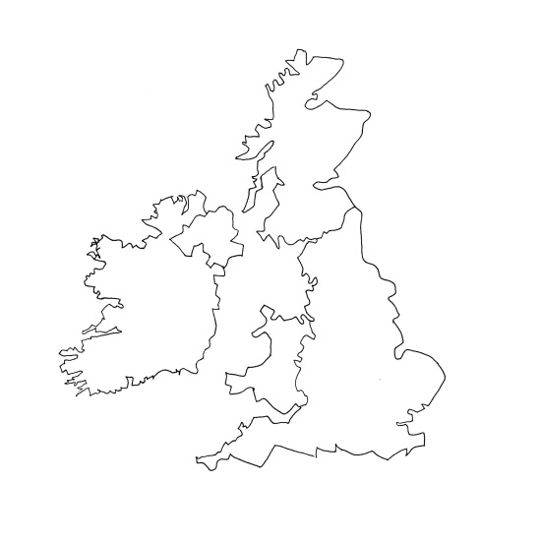

Speaker 3’s best friend:
KEY:
1: (SCOTLAND)
2: (NORTHERN IRELAND)
3: (WALES)

42-A-L-UK [WITH 1 AUDIO – 1 British person]
42.- LISTEN TO THE RECORDING AND DECIDE WHICH IS THE CORRECT OPTION IN EACH SENTENCE.

1.- It is the anniversary of the Gunpowder Plot / the Gunplot Powder.
2.- Bonfire / Guy Fawkes was in charge of setting off the gunpowder.
3.- We make guys - which are homemade dolls / dummies.
4.- It’s typical for children to go around asking for a penny / tennis for the guy to buy fireworks and sparklers / toys.
5.- There are torch-lit / talking processions all over England.
6.- There are work and games / fireworks displays and that’s definitely the best part.
KEY: 1.- the Gunpowder Plot 2.- Guy Fawkes 3.- dummies 4.- penny … sparklers 5.- torch-lit 6.- fireworks displays

43-A-L-UK [WITH 3 AUDIOS – 1 American male + 1 female]
43.- LISTEN TO THE RECORDING AND DECIDE IF THESE SENTENCES ARE TRUE (T) OR FALSE (F).
1.- Kelly arrived in England after Lola. T / F
2.- Lola knew she shouldn’t kiss her boyfriend’s parents when she met them. T / F
3.- You can ask personal questions if you don’t talk loudly. T / F
4.- You seem angry when you talk loudly. T / F
5.- Kelly knows he has to say “thank you”, but not “please” and “sorry”. T / F
KEY: 1.- T 2.- F 3.- F 4.- T 5.- F

