UNIT 9
01-P-G-MV2
01.- MODAL VERBS MUST AND MUSTN’T. STRUCTURE AND USES.
[Modalverben must und musn‘t. Struktur und Verwendung.]
[Los verbos modales must y mustn’t. Estructura y usos.]
The basic structure for must / mustn’t is:
SUBJECT | MUST or MUSTN’T | VERB (infinitive)
I | must  /  mustn’t | go  stop  drink water  wash our hands  study  make noise
you
he/she/it
we
you
they

Pay attention!!!
Must is a modal verb.
In the affirmative we use must to speak about obligation.
Ex: You must study a lot to learn English.
In the negative we use mustn’t to speak about prohibition.
Ex: You mustn’t smoke in public places.

02-A-G-MV2
02.- CHOOSE THE CORRECT OPTION: MUST (OBLIGATION) OR MUSTN’T (PROHIBITION).
[Wähle die richtige Möglichkeit aus: must (Pflicht) oder mustn‘t (Verbot).]
[Elige la opción correcta: must (obligación) o mustn’t (prohibición).]
1.- We don’t have any shampoo. We must / mustn’t go to the supermarket.
2.- You must / mustn’t wash your teeth before going to sleep.
3.- We must / mustn’t eat in the classroom.
4.-You must / mustn’t eat fruit and vegetables to be healthy.
5.- Shhh! You must / mustn’t talk loud in the library.
KEY: 1.- must 2.- must 3.- mustn’t 4.- must 5.- mustn’t

03-A-G-MV2
03.- THERE IS A MISTAKE IN EVERY SENTENCE. REWRITE THE SENTENCES WITHOUT THE MISTAKES.
[In jedem Satz wurde ein Fehler eingebaut. Schreib fehlerlos die Sätze neu.]
[Hay un error en cada frase. Reescribe las frases sin los errores. ]
1.- Children musn’t interrupt when adults are speaking.
_____________________________________________.
2.- You must to go to the doctor because you’re very ill.
_____________________________________________.
3.- People don’t must smoke in public places.
_____________________________________________.
4.- She musts do her homework.
_____________________________________________.
KEY:
1.- Children mustn’t interrupt when adults are speaking
2.- You must go to the doctor because you’re very ill
3.- People mustn’t smoke in public places
4.- She must do her homework

04-A-R-MV4
04.- MODAL VERBS. COMPLETE THE FOLLOWING SENTENCES WITH MUST OR MUSTN’T AND A VERB FROM THE BOX.
[Madalverben. Vervollständige folgende Sätze mit must oder mustn‘t und einem Verb aus dem Kasten.]
[Verbos modales. Completa las siguientes frases con must o mustn’t y un verbo del recuadro.]
turn | take | drive | turn | stop

Example.- 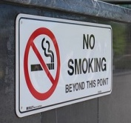 You mustn’t smoke near this building.
1.- 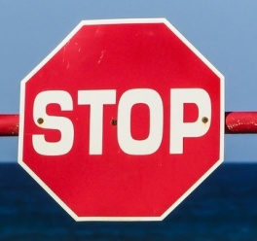 You __________ _________ you car here.
2.- 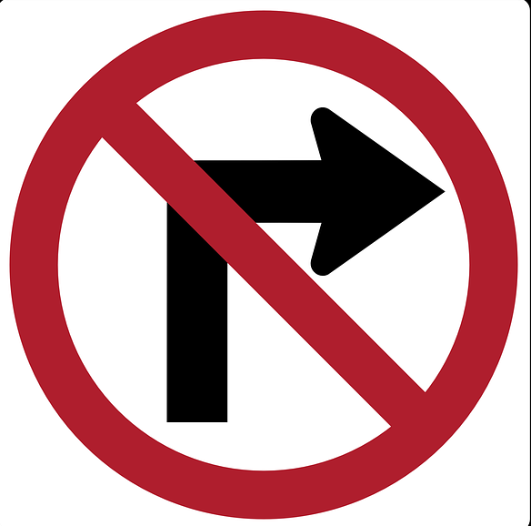 You __________ _________ right.
3.- 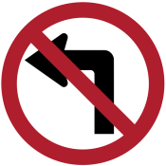 You __________ _________ left.
4.- 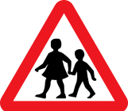 You __________ _________ very slowly because there are children.
5.- 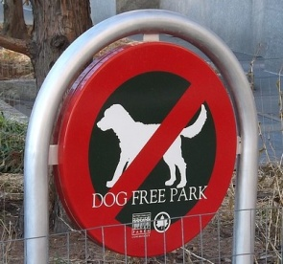 You __________ _________ your dog into this park.
KEY:
1.- must stop 2.- mustn’t turn 3.- mustn’t turn 4.- must drive 5.- mustn’t take

05-A-R-MV4
05.- MODAL VERBS. WRITE RULES ABOUT RIDING A SEGWAY USING MUST OR MUSTN’T AND THE PROMPTS FOR EACH SENTENCE.
[Modalverben. Schreibe Regeln über die Verwendung eines Segways auf und verwende dabei must oder mustn‘t sowie die Stichwӧrter des jeweiligen Satzes.]
[Verbos modales. Escribe reglas sobre cómo llevar un Segway usando must o mustn’t y la información que hay en cada frase.]
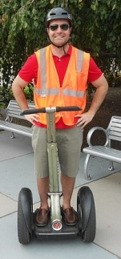 Rules for riding a Segway!
1.- You / ride in shopping centres
________________________________________.
2.- You / wear a helmet.
________________________________________.
3.- You / go faster than 12 km/h on the pavement.
________________________________________.
4.- You / listen to music.
________________________________________.
5.- You / wear bright colours in the dark.
________________________________________.
6.- You / use a light in the dark.
________________________________________.
KEY:
1.- You mustn’t ride in shopping centres
2.- You must wear a helmet
3.- You mustn’t go faster than 12 km/h on the pavement
4.- You mustn’t listen to music.
5.- You must wear bright colours in the dark
6.- You must use a light in the dark.

06-A-L-MV4 [WITH 1 AUDIO]
06.- LISTEN TO LITTLE JANE AND HER DAD TALKING ABOUT SCHOOL RULES. COMPLETE THE DIALOGUE WITH THE MISSING WORDS.
[Hör Dir das Gespräch zwischen der kleinen Jane und ihren Vater über die Schulregeln an. Vervollständige den Dialog mit den fehlenden Wӧrtern.]
[Escucha a la pequeña Jane y a su padre hablando sobre las normas en la escuela. Completa el diálogo con las palabras que faltan.]
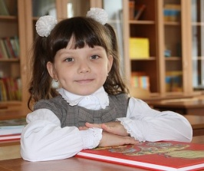
Jane: I had a problem at school today because I took my hamster to class.
Dad: But you _______ _______ animals to school!
Jane: Why, Dad?
Dad: Because it’s a rule.
Jane: But there are too many rules at school. I _______ _______ and I _______ _______ in class!
Dad: That’s right. And there are other things you must do.
Jane: Yes! We _______ _______ our uniform and we _______ _______ lots of homework.
Dad: And you _______ _______ to bed early or you’ll be tired tomorrow morning.

KEY:
Dad: Why are you so sad, Jane?
Jane: I had a problem at school today because I took my hamster to class.
Dad: But you mustn’t take animals to school!
Jane: Why, Dad?
Dad: Because it’s a rule.
Jane: But there are too many rules at school. I mustn’t eat and I mustn’t shout in class!
Dad: That’s right. And there are other things you must do.
Jane: Yes! We must wear our uniform and we must do lots of homework.
Dad: And you must go to bed early or you’ll be tired tomorrow morning.

07-P-G-MV3
07.- MODAL VERBS SHOULD AND SHOULDN’T. STRUCTURE AND USES.
[Modalverben should und shouldn‘t. Struktur und Verwendung.]
[Los verbos modales should y shouldn’t. Estructura y usos.]
The basic structure for should / shouldn’t is:
SUBJECT + SHOULD / SHOULDN’T + MAIN VERB IN INFINITIVE

We use should and shouldn’t to give advice or talk about what we think is right or wrong.
You should means something like I think it is a good idea for you to do it.
You shouldn’t means something like I think it is a bad idea for you to do it.

08-A-G-MV3
08.-SHOULD / SHOULDN’T. CHOOSE THE BEST OPTION.
[Should /shouldn‘t. Wähle die beste Mӧglichkeit aus.]
[Should / shouldn’t. Elige la mejor opción.]
1.- Jenny, you have asthma. I think you should / shouldn’t smoke so much.
2.- If you want to be healthy, you should / shouldn’t do some exercise.
3.- I think we should / shouldn’t reserve our hotel in advance.
4.- Children should / shouldn’t watch so much TV.
5.- It’s very cold. You should / shouldn’t wear a coat.
KEY: 1.- shouldn’t 2.- should 3.- should 4.- shouldn’t 5.- should

09-A-G-MV3
09.- COMPLETE THE FOLLOWING SENTENCES WITH SHOULD OR SHOULDN’T.
[Vervollständige die folgenden Sätze mit should oder shouldn‘t.]
[Completa las siguientes frases con should o shouldn’t.]
1.- I have a party on Saturday. What ________ I wear? My pink or my yellow dress?
2.- Tom ________ eat a lot of sweets. They’re bad for his teeth.
3.- If it’s rainy, you ________ take an umbrella.
4.- You have an exam tomorrow morning. You ________ go dancing tonight.
5.- ________ I drink a hot drink if I have a sore throat?, Yes, you should, but not too hot.
KEY: 1.- should 2.- shouldn’t 3.- should 4.- shouldn’t 5.- should

10-A-R-MV4
10.- MODAL VERBS. COMPLETE THE FOLLOWING SENTENCES WITH SHOULD OR SHOULDN’T AND A VERB FROM THE BOX.
[Modalverben. Vervollständige die folgenden Sätze mit should oder shouldn‘t und einem Verb aus dem Kasten.]
[Verbos modales. Completa las siguientes frases con should o shouldn’t y un verbo del recuadro.]
shouldn’t have | shouldn’t drink | should eat | shouldn’t drive

1.- 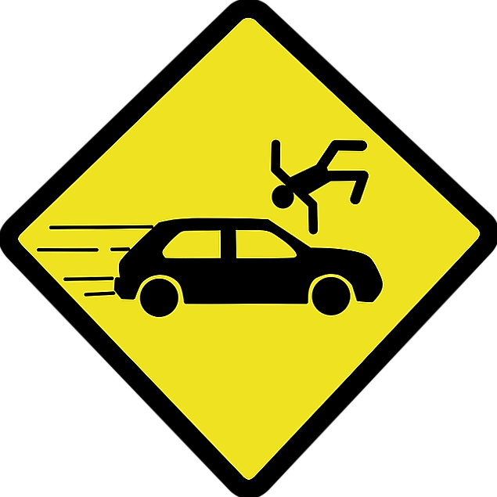 You _____________ fast. You can have an accident.
2.- 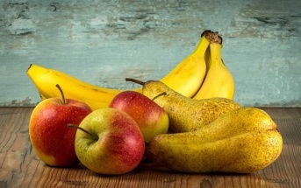 You _____________ fruit every day. It’s good for you.
3.- 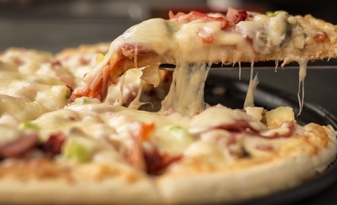 You _____________ pizza every day. It isn’t really.
4.- 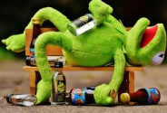 You _____________ so much alcohol or you’ll be drunk.

KEY: 1.- shouldn’t drive 2.- should eat 3.- shouldn’t have 4.- shouldn’t drink

11-A-R-MV4
11.- MODAL VERBS. READ THE FOLLOWING SIGNS AND CHOOSE THE CORRECT ANSWER.
[Modalverben. Lies folgende Schilder und wähle die richtige Antwort aus.]
[Verbos Modales. Lee los siguientes carteles y elige la respuesta correcta.]
1.-

No Smoking
a.- You mustn’t smoke here.
b.- You should smoke here.
c.- You must smoke here.
2.-
Keep bottles in cool place
a.- You shouldn’t keep bottles in a cool place.
b.- You should keep bottles in a cool place.
c.- You mustn’t keep bottles in a cool place.
3.-
Keep Off The Grass
a.- You mustn’t walk on the grass.
b.- You must walk on the grass.
c.- You should walk on the grass.
4.-
Private Property
a.- You must go into the house.
b.- You should go into the house.
c.- You shouldn’t go into the house.
5.-
Don't Iron
a.- You should iron this shirt.
b.- You must iron this shirt.
c.- You mustn’t iron this shirt.
KEY: 1.- a 2.- b 3.- a 4.- c 5.- c

12-A-L-MV4 [WITH 1 AUDIO]
12.- MODAL VERBS. LISTEN TO THE WELCOME SPEECH AT CAMP MEDUSA. CHOOSE THE CORRECT OPTION (a, b).
[Modalverben. Hӧr Dir die Willkommensrede des Camps Medusa an. Wähle die richtige Mӧglichkeit aus (a, b).]
[Verbos modales. Escucha el mensaje de bienvenida al Campamento Medusa. Elige la opción correcta (a, b).]
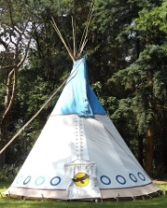
1.- Children with allergies _________ report to the monitors immediately upon arrival at the camp.
a.- should b.- shouldn’t
2.- You _________ get up at 7:00 in the morning.
a.- mustn’t b.- must
3.- After breakfast you _________ walk around the tents.
a.- should b.- shouldn’t
4.- After lunchtime you _________ keep quiet.
a.- mustn’t b.- must
5.- You _________ walk around the forest without a monitor.
a.- mustn’t b.- must
6.- You must _________ go to sleep at 10:00.
a.- mustn’t b.- must
KEY: 1.- a 2.- b 3.- b 4.- b 5.- a 6.- b

13-A-L-MV4 [WITH 1 AUDIO]
13.- MODAL VERBS. LISTEN TO THE RECORDING ABOUT THE METRO AT TOKYO AND CHOOSE THE CORRECT OPTION.
[Modalverben. Hӧr Dir die Aufnahme über die Metro in Tokio an und wähle die richtige Mӧglichkeit aus (a, b, c).]
[Verbos modales. Escribe reglas sobre el metro de Tokio y elige la opción correcta (a, b, c).]
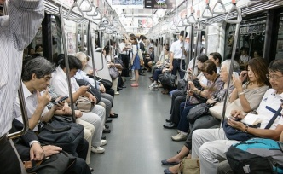
1.- You ________ have a valid ticket to travel.
a.- must b.- mustn’t c.- shouldn’t
2.- You ________ stand behind the yellow line on the platform.
a.- must b.- mustn’t c.- shouldn’t
3.- You ________ shout on the trains.
a.- must b.- mustn’t c.- shouldn’t
4.- You mustn’t take bikes on trains.
a.- must b.- mustn’t c.- shouldn’t
5.- You mustn’t play musical instruments on the trains.
a.- must b.- mustn’t c.- shouldn’t
6.- You mustn’t eat or drink on trains.
a.- must b.- mustn’t c.- shouldn’t
KEY: 1.- a 2.- a 3.- b 4.- b 5.- b 6.- b

14-P-G-SOMEANY
14.- USES OF SOME AND ANY.
[Verwendung von some und any.]
[Usos de some y any.]
We use some before countable and uncountable nouns in:
- affirmative sentences:
Ex: There is some milk in the bottle. / There are some biscuits in the box.
We use any before countable and uncountable nouns in:
- negative sentences:
Ex: There isn’t any beer in the bottle. / There aren’t any apples in the basket.
- questions:
Ex: Is there any wine in the bottle? / Are there any bananas on the table?

15-A-G-SOMEANY
15.- SOME / ANY. CHOOSE THE CORRECT OPTION.
[Some / any. Wähle die richtige Mӧglichkeit aus.]
[Some / any. Elige la opción correcta.]
1.- I’d like to buy some / any apples, please.
2.- My cousin Mary doesn’t drink some / any beer.
3.- This morning I bought some / any for dinner.
4.- Do we have some / any milk left for breakfast?
5.- This evening I’m going to buy some / any cherries for tomorrow’s picnic.
KEY: 1.- some 2.- any 3.- some 4.- any 5.- some

16-A-G-SOMEANY
16.- COMPLETE THE FOLLOWING SENTENCES WITH SOME OR ANY.
[Vervollständige die folgenden Sätze mit some oder any.]
[Completa las siguientes frases con some o any.]
1.- There isn’t ________ sugar in my tea.
2.- Are there ________ potatoes in the basket?
3.- Susan bought ________ blueberries for the children yesterday.
4.- Right now Alison is buying ________ bananas at the greengrocer’s.
5.- Today we don’t have ________ biscuits for breakfast.
KEY: 1.- any 2.- any 3.- some 4.- some 5.- any

17-A-V-FDDRNK
17.- AT THE GREENGROCER’S. DRAG AND DROP THE FOLLOWING FRUITS FROM THE BOX ON THE RIGHT PICTURES.
[Beim Gemüsehändler. Ordne die folgenden Früchte aus dem Kasten per Drag-and-drop den geeigneten Bildern zu.]
[En la verdulería. Agarra y suelta las siguientes frutas del recuadro con sus imágenes correspondientes.]
apples | bananas | blueberries | cherries
strawberries | pears | oranges | grapes
1.- 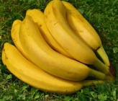 2.- 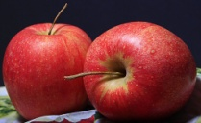 3.- 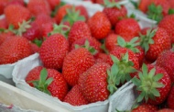 4.- 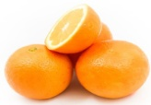
5.- 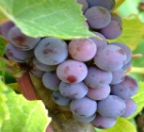 6.- 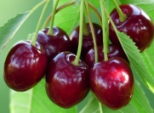 7.- 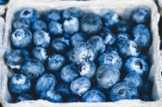 8.- 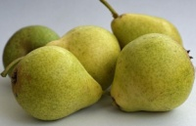
KEY: 1.- bananas 2.- apples 3.- strawberries 4.- oranges
5.- grapes 6.- cherries 7.- blueberries 8.- pears
18-A-V-FDDRNK
18.- AT THE GREENGROCER’S. DRAG AND DROP THE FOLLOWING VEGETABLES FROM THE BOX ON THE RIGHT PICTURES.
[Beim Gemüsehändler. Ordne die folgenden Gemüse aus dem Kasten den entsprechenden Bildern per Drag-and-drop zu.]
[En la verdulería. Agarra y suelta las siguientes verduras del recuadro con sus imágenes correspondientes.]

lettuce | cucumbers | potatoes | peppers
tomatoes | broccoli | onions | carrots

1.- 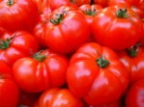 2.- 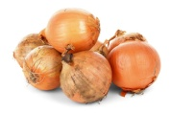 3.- 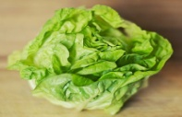 4.- 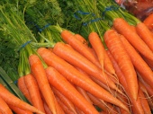
5.- 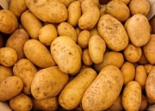 6.- 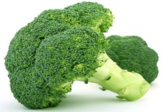 7.- 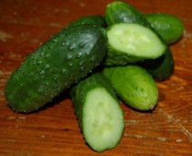 8.- 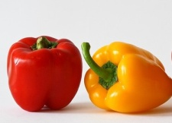
KEY: 1.- tomatoes 2.- onions 3.- lettuce 4.- carrots
5.- potatoes 6.- broccoli 7.- cucumbers 8.- peppers

19-A-V-FDDRNK
19.- AT THE GROCER’S. DRAG AND DROP THE FOLLOWING DRINKS FROM THE BOX ON THE RIGHT PICTURES.
[Beim Lebensmittelhändler. Ordne die folgenden Getränke aus dem Kasten per Drag-and-drop den entsprechenden Bildern zu.]
[En la tienda de comestibles. Agarra y suelta las siguientes frutas del recuadro con sus imágenes correspondientes.]
a carton of juice | bottles of water | bottles of beer
a bottle of wine | a can of coke | bottles of milk
1.- 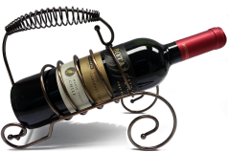 2.- 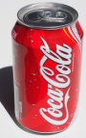 3.- 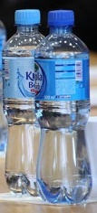 4.- 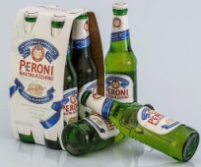 5.- 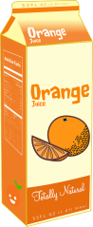 6.- 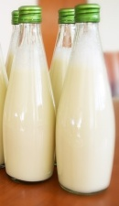

KEY: 1.- a bottle of wine 2.- a can of coke 3.- bottles of water
4.- bottles of beer 5.- a carton of juice 6.- bottles of milk
20-A-V-FDDRNK
20.- AT THE GROCER’S. DRAG AND DROP THE FOLLOWING KINDS OF FOOD FROM THE BOX ON THE RIGHT PICTURES.
[Beim Gemüsehändler. Ordne die folgenden Lebensmittelarten aus dem Kasten den entsprechenden Bildern zu.]
[En la tienda de comestibles. Agarra y suelta los siguientes tipos de comida del recuadro con sus imágenes correspondientes.]
coffee | bread | olive oil | ham
sugar | eggs | biscuits | cheese
1.- 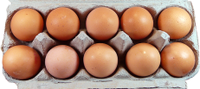 2.- 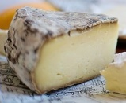 3.- 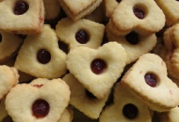 4.- 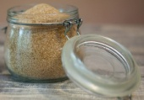
5.- 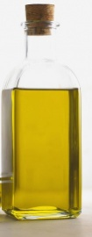 6.- 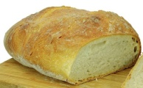 7.- 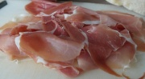 8.- 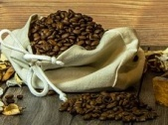
KEY: 1.- eggs 2.- cheese 3.- biscuits 4.- sugar
5.- olive oil 6.- bread 7.- ham 8.- coffee
21-A-R-SHOP
21.- AT THE MARKET. READ THE FOLLOWING TEXT AND CLICK ON TRUE (T) OR FALSE (F).
[Auf dem Markt. Lies folgenden Text und klicke richtig (T) oder falsch (F) an.]
[En el mercado. Escucha la grabación y haz click en verdadero (T) o falso (F).]
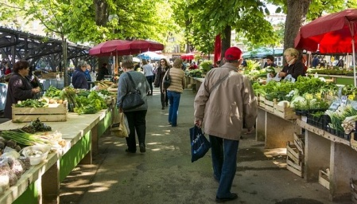
AT THE MARKET
I love doing the shopping on Saturday mornings. I usually meet my friend Jenny at 10:00 and have breakfast with her in a nice coffee-shop near my home. Later, I always walk to the market in my neighbourhood.
Yesterday I needed to buy some food to make a salad. I bought a lettuce, some cucumbers and some tomatoes. I didn’t buy any onions because I still had some at home. I also bought some potatoes and some eggs because I didn’t have any at home and I wanted to make a Spanish omelette.
1.- I usually have breakfast in the market. T / F
2.- I always take the bus to the market. T / F
3.- Yesterday I had some onions at home. T / F
4.- Yesterday I bought some food to make a salad. T / F
5.- Yesterday I bought some eggs because I didn’t have any at home. T / F
KEY: 1.- F 2.- F 3.- T 4.- T 5.- T

22-A-R-SHOP
22.- AT THE GREENGROCER’S. ORDER THE FOLLOWING DIALOGUE.
[Beim Gemüsehändler. Ordne den folgenden Dialog.]
[En la verdulería. Ordena el siguiente diálogo.]
Thomas: | Greengrocer:
Ok, I’ll take half a kilo of strawberries. And also, a bunch of bananas. How much is it? | The strawberries I got today are very sweet and juicy.
Fine, thanks. Today I am making a potato salad for lunch, so I need a kilo of potatoes. | Right away. Anything else?
Good morning. | That’ll be €27, sir.
No, I don’t think so. Yes – I forgot! I need some fruit for dessert. What do you recommend? | Hello, how are you?
Well, one head of lettuce, half a kilo of cucumbers and half a kilo of tomatoes. Oh, and some broccoli. | Ok, here are the potatoes. Do you need anything else?

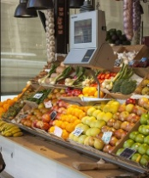
Thomas:
Greengrocer:
Thomas:
Greengrocer:
Thomas:
Greengrocer:
Thomas:
Greengrocer:
Thomas:
Greengrocer:
KEY:
Thomas: Good morning.
Greengrocer: Hello, how are you?
Thomas: Fine, thanks. Today I am making a potato salad for lunch, so I need a kilo of potatoes.
Greengrocer: Ok, here are the potatoes. Do you need anything else?
Thomas: Well, one head of lettuce, half a kilo of cucumbers and half a kilo of tomatoes. Oh, and some broccoli.
Greengrocer: Right away. Anything else?
Thomas: No, I don’t think so. Yes – I forgot! I need some fruit for dessert. What do you recommend?
Greengrocer: The strawberries I got today are very sweet and juicy.
Thomas: Ok, I’ll take half a kilo of strawberries. And also, a bunch of bananas. How much is it?
Greengrocer: That’ll be €27, sir.

23-A-R-SHOP [WITH 1 AUDIO]
23.- AT THE GROCER’S. READ AND LISTEN TO THE FOLLOWING DIALOGUE AND CHOOSE THE CORRECT ANSWER.
[Beim Lebensmittelhändler. Lies und Hӧr Dir den folgenden Dialog an und wähle die richtige Antwort aus.]
[En la tienda de comestibles. Lee y escucha el diálogo siguiente y elige la respuesta correcta.]
Shop-assistant: Good morning!
Angela: Good morning! I would like to have two dozen eggs, please.
Shop-assistant: Anything else, madam?
Angela: Yes, three bottles of milk and a piece of cheese.
Shop-assistant: Is that all?
Angela: No, it isn’t. I also want two bottles of olive oil and half a kilo of cured ham.
Shop-assistant: Sure. That will be 12 euros.
1.- Angela wants _________ dozen eggs.
a.- one b.- two c.- three
2.- Angela also buys _________.
a.- milk and juice b.- milk and biscuits c.- milk and cheese
3.- Angela wants two bottles of _________.
a.- milk b.- olive oil c.- beer
4.- Angela buys half a kilo of _________.
a.- ham b.- bread c.- cheese
5.- Angela’s shopping costs _________.
a.- 20 euros b.- 12 euros c.- 32 euros
KEY: 1.- b 2.- c 3.- b 4.- a 5.- b

24-A-L-SHOP [WITH 1 AUDIO]
24.- AT THE GROCER’S. LISTEN TO THE FOLLOWING DIALOGUE AND CLICK ON TRUE (T) OR FALSE (F).
[Beim Gemüsehändler. Hӧr Dir den folgenden Dialog an und klicke richtig (T) oder falsch (F) an.]
[En la tienda de comestibles. Escucha la grabación y haz click en verdadero (T) o falso (F).]
1.- Dawson wants one kilo of sugar. T / F
2.- Dawson also buys olive oil. T / F
3.- Dawson doesn’t want any coffee. T / F
4.- Dawson buys a packet of biscuits. T / F
5.- Dawson’s shopping costs twelve euros. T / F

KEY: 1.- F 2.- T 3.- F 4.- T 5.- F

25-A-L-SHOP [WITH 1 AUDIO]
25.- AT THE GREENGROCER’S. LISTEN TO THE FOLLOWING DIALOGUE AND COMPLETE THE MISSING WORDS.
[Beim Gemüsehändler. Hӧr Dir den folgenden Dialog an und vervollständige diesen mit den fehlenden Wӧrtern.]
[En la verdulería. Escucha el diálogo y completa las palabras que faltan.]
Abigail: Good morning.
Greengrocer: Hello, how are you?
Abigail: Fine, thanks. Today I am making a ________ ________ for lunch, so I need a kilo of ________ .
Greengrocer: Ok, here are the potatoes. Do you need anything else?
Abigail: Well, one head of ________, half a kilo of ________ and half a kilo of ________. Oh, and some ________.
Greengrocer: Right away. Anything else?
Abigail: No, I don’t think so. Yes – I forgot! I need some fruit for dessert. What do you recommend?
Greengrocer: The ________ I got today are very sweet and juicy.
Abigail: Ok, I’ll take half a kilo of strawberries. And also, a bunch of ________. How much is it?
Greengrocer: That’ll be €27, madam.
KEY:
Abigail: Good morning.
Greengrocer: Hello, how are you?
Abigail: Fine, thanks. Today I am making a potato salad for lunch, so I need a kilo of potatoes.
Greengrocer: Ok, here are the potatoes. Do you need anything else?
Abigail: Well, one head of lettuce, half a kilo of cucumbers and half a kilo of tomatoes. Oh, and some broccoli.
Greengrocer: Right away. Anything else?
Abigail: No, I don’t think so. Yes – I forgot! I need some fruit for dessert. What do you recommend?
Greengrocer: The strawberries I got today are very sweet and juicy.
Abigail: Ok, I’ll take half a kilo of strawberries. And also, a bunch of bananas. How much is it?
Greengrocer: That’ll be €27, sir.

26-A-L-SHOP [WITH 1 AUDIO]
26.- AT THE MARKET. LISTEN TO THE FOLLOWING TEXT AND CHOOSE THE CORRECT ANSWER.
[Auf dem Markt. Hӧr Dir folgenden Text an und wähle die richtige Antwort aus.]
[En el mercado. Escucha la grabación y haz elige la respuesta correcta.]
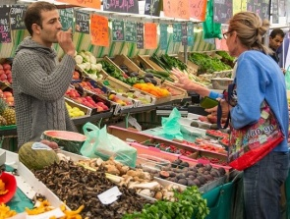
1.- On Saturday mornings I usually have __________ in a coffee-shop.
a.- breakfast b.- lunch c.- dinner
2.- I always go __________ to the market.
a.- by car b.- by bus c.- on foot
3.- Yesterday I __________ any onions in the market because I had some at home. a.- buyed b.- bought c.- didn’t buy
4.- Yesterday I bought some food to make a __________.
a.- paella b.- salad c.- soup
5.- Yesterday I bought some __________ because I didn’t have any at home.
a.- eggs b.- biscuits c.- onions

KEY: 1.- a 2.- b 3.- b 4.- b 5.- a

27-P-V-NEEDS
27.- DAILY NEEDS. LOOK AT THESE THINGS WE USE IN OUR DAILY LIVES.
[Tägliche Bedürfnisse. Sieh dir folgende Sachen an, die wir in unserem alltäglichen Leben gebrauchen.]
[Necesidades diarias. Mira estas cosas que usamos en nuestras vidas diarias.]
soap 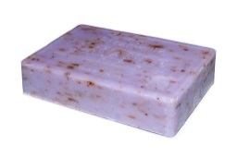 | shower gel  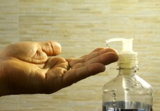 | shampoo  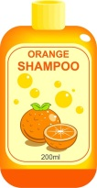 | hairbrush  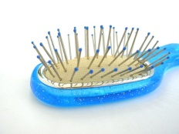

plasters  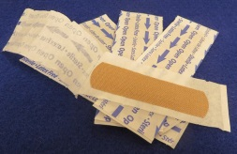 |  | ibuprofen  tablets  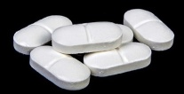 |  | cough syrup  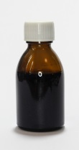 |  | toilet paper  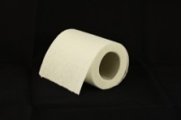 |  | toothpaste and toothbrush  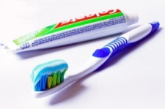
28-A-V-NEEDS
28.- DAILY NEEDS. DRAG AND DROP THE NAMES ON THE RIGHT PICTURES.
[Tägliche Bedürfnisse. Ordne per Drag-and-drop die Namen den richtigen Bildern zu.]
[Necesidades diarias. Arrastra y suelta los nombres en las fotos correctas.]
hairbrush | soap | toilet paper | shampoo | shower gel

1.- 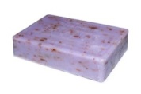 2.- 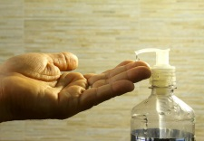 3.- 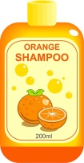 4.- 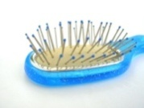 5.- 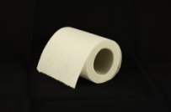
KEY: 1.- soap 2.- shower gel 3.- shampoo 4.- hairbrush 5.- toilet paper

29-A-V-NEEDS
29.- DAILY NEEDS. CHOOSE THE CORRECT NAME FOR EVERY PRODUCT.
[Tägliche Bedürfnisse. Wähle den geeigneten Begriff für jedes Produkt aus.]
[Necesidades diarias. Elige el nombre correcto para cada producto.]
1 | 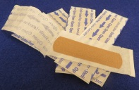 | a) tablets  b) plasters  c) paste | 3 | 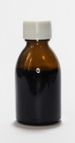 | a) syrup paste  b) cough brush  c) cough syrup
2 |  | a) ibuprofen tablets  b) ibuprofen plasters  c) ibuprofen syrup | 4 | 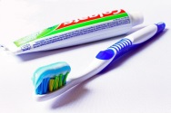 | a) toothpaste and toothbrush  b) toothplaster and toothbrush  c) toothpaste and toothcough
KEY: 1.- b 2.- a 3.- a 4.- a

30-A-R-NEEDS
30.- DAILY NEEDS. READ THE DESCRIPTIONS AND FILL IN THE GAPS WITH THE CORRECT WORD.
[Tägliche Bedürfnisse. Lies die Beschreibung und setze in die Lücken das richtige Wort ein.]
[Necesidades diarias. Lee las descripciones y rellena los huecos con la palabra correcta. ]
1.- I wash my hair with _ _ _ _ _ _ _.
2.- When I have a headache, I take an _ _ _ _ _ _ _ _ _ _ _ _ _ _ _ .
3.- If I cut my finger, I put a _ _ _ _ _ _ _ on it.
4.- I brush my hair with my _ _ _ _ _ _ _ _ _.
KEY: 1.- shampoo 2.- ibuprofen tablet 3.- plaster 4.- hairbrush

31-A-R-NEEDS
31.- DAILY NEEDS: READ THE TEXT AND SAY IF THE SENTENCES ARE TRUE (T) OR FALSE (F).
[Tägliche Bedürfnisse. Lies den Text und entscheide ob die Sätze richtig (T) oder falsch (F) sind.]
[Necesidades diarias. Lee el texto y di si las frases son verdaderas (T) o falsas (F).]
Noemi is from Spain, but she is living in England now and the first time she went shopping with a friend, she was really amazed. In the supermarket there were a hundred types of shampoos and shower gels. After twenty minutes, she chose a mandarin shampoo. She also took a chocolate and mint shower gel, but her friend said that he usually uses soap when he has a shower, so she decided to try the soap, so she didn’t buy the shower gel. She also bought some pink toilet paper, a blue hairbrush, a purple toothbrush and a strawberry toothpaste tube.
Then, she wanted to go to the chemist’s to buy ibuprofen tablets for her migraine and cough syrup for her cold, but her friend said, “you can buy them here, in the supermarket”. She was very surprised and, although in Spain they are expensive, they were very cheap!
1.- There were a lot of types of shampoos and gels in the supermarket. T / F
2.- Noemi didn’t buy any soap. T / F
3.- She bought some pink toilet paper and a purple hairbrush. T / F
4.- She bought the medicine at the chemist’s. T / F
5.- Ibuprofen tablets are cheap England in and expensive in Spain. T / F

KEY: 1.- T 2.- F 3.- F 4.- F 5.- T

32-A-R-NEEDS
32.- WRITE YOUR OWN SHOPPING LIST. TAKE NOTES OF THE DAILY NEEDS PRODUCTS YOU NEED TO BUY.
[Erstelle Dir deine eigne Einkaufliste. Notiere die Produkte, welche du täglich benutzt und einkaufen musst. ]
[Escribe tu propia lista de la compra. Anota los productos de necesidades diarias que necesites comprar.]
SHOPPING LIST
__________________________
__________________________
__________________________
__________________________
__________________________
__________________________
__________________________
__________________________
__________________________

33-P-V-DOC
33.- AT THE DOCTOR’S. PAY ATTENTION TO THE FOLLOWING VOCABULARY.
[Beim Arzt. Sei aufmerksam mit dem folgenden Vokabular.]
[En la consulta del médico. Presta atención al siguiente vocabulario.]
1.- 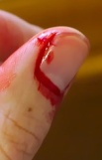 I have a cut in my finger. 2.- 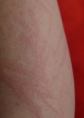 I have a rash.
3.- 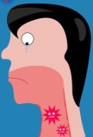 I have a sore throat.4.- 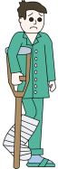 I have a broken leg.
5.- I have a cold. 6.- I have a backache.

34-A-V-DOC
34.- AT THE DOCTOR’S. MATCH THE ILLNESSES WITH THE SYMPTOMS OR CAUSES AND THE IMAGES.
[Beim Arzt. Verbinde die Krankheiten mit ihren entsprechenden Symptomen oder Ursachen und den Bildern. ]
[En la consulta del médico. Une las imágenes con los síntomas o causas.]
1.- a.- I fell down the stairs.
2.- b.- I ‘m allergic to nylon.
3.- c.- I cut my finger when I cut some carrots.
4.- d.- It hurts a lot, so today I’m at the physio.
5.- e.- I can’t drink very well.
6.- f.- I have a temperature and can’t stop sneezing.
KEY: 1.- b 2.- d 3.- e 4.- f 5.- c 6.- a

35-A-V-DOC
35.- AT THE DOCTOR’S. DRAG AND DROP THE CORRECT ILLNESSES AND SYMPTOMS OR CAUSES IN THE TABLE.
[Beim Arzt. Ziehe per Drag-and-drop die Krankheiten und die Symptome oder Ursachen in die Tabelle.]
[En la consulta del médico. Agarra y suelta las enfermedades y los síntomas o causas en la tabla.]
ILLNESSES
I have a rash. | I have a broken leg. | I have a sore throat.

SYMPTOMS OR CAUSES
I fell down the stairs. | I can’t drink very well. | I ‘m allergic to nylon.

 | 1.- | 2.- | 3.-
ILLNESSES

SYMPTOMS /
CAUSES

KEY:
 | 1.- | 2.- | 3.-
ILLNESSES | I have a sore throat. | I have a broken leg. | I have a rash.
SYMPTOMS /  CAUSES | I can’t drink very well. | I fell down the stairs. | I ‘m allergic to nylon.

36-A-V-DOC
36.- AT THE DOCTOR’S. DRAG AND DROP THE CORRECT ILLNESSES AND SYMPTOMS OR CAUSES IN THE TABLE.
[Beim Arzt. Ziehe per Drag-and-drop die Krankheiten und die Symptome oder Ursachen in die Tabelle.]
[En la consulta del médico. Agarra y suelta las enfermedades y los síntomas o causas en la tabla.]
ILLNESSES
I have a backache. | I have a cold. | I have a cut in my finger.

SYMPTOMS OR CAUSES
I have a temperature and can’t stop coughing. | I cut my finger when I cut some carrots. | It hurts a lot, so today I’m at the physio.

 | 1.- | ´2.- | 3.-
ILLNESSES

SYMPTOMS /
CAUSES

KEY:
 | 1.- | ´2.- | 3.-
ILLNESSES | I have a cut in my finger. | I have a backache. | I have a cold.
SYMPTOMS /  CAUSES | I cut my finger when I cut some carrots. | It hurts a lot, so today I’m at the physio. | I have a temperature and can’t stop coughing.

37-A-L-DOC [WITH 1 AUDIO]
37.- LISTEN TO THE FOLLOWING DIALOGUE AT THE DOCTOR’S. CHOOSE THE CORRECT OPTION.
[Hör Dir den folgenden Dialog beim Arzt an. Wähle die richtige Möglichkeit aus.]
[Escucha el siguiente diálogo en la consulta del médico. Elige la opción correcta.]
1.- Mr Smith has a __________.
a.- cold b.- sore throat c.- headache
2.- He started feeling bad ________ days ago.
a.- two b.- four c.- three
3.- He ________ a temperature.
a.- doesn’t have b.- have c.- has
4.- The doctor prescribes him some__________.
a.- ibuprofen b.- antibiotics c.- syrup
KEY: 1.- b 2.- c 3.- c 4.- b

38-A-L-DOC [WITH 1 AUDIO]
38.- LISTEN TO ANN AT THE CHEMIST’S AND CLICK ON TRUE (T) OR FALSE (F).
[Hör Ann in der Apotheke an und klicke richtig (T) oder falsch (F) an.]
[Escucha a Ann en la farmacia y haz click en verdadero (T) o falso (F).]
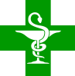 1.- Ann doesn’t have a prescription for her medicine. T / F
2.- Ann wants to buy the syrup. T / F
3.- Ann must take three teaspoonfuls once a day. T / F
4.- Ann should be careful if she drives after taking her medicine. T / F
5.- Ann’s medicine costs 12 euros. T / F
KEY: 1.- F 2.- T 3.- F 4.- T 5.- F

39-A-L-DOC [WITH 1 AUDIO]
39.- LISTEN TO MAGGIE TALKING ABOUT POOR LITTLE ANDY. ANSWER THE QUESTIONS COMPLETING THE ANSWERS GIVEN.
[Hör Maggie dabei zu wie diese über den armen kleinen Andy spricht. Beantworte die Fragen, indem Du die gegebenen Antworten vervollständigst.]
[Escucha a Maggie hablando sobre el pequeño Andy. Responde a las preguntas completando las respuestas dadas.]
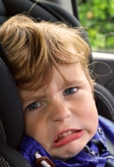 Poor little Andy
1.- When did Andy have a problem at school?
He had a problem _____________.
2.- What happened to Andy at school?
He __________ down the ____________.
3.- Did his teacher call his mum at home?
No, he _______.
4.- Did his mum pick him up at school?
Yes, she _______.
5.- Doesn’t Andy like going to the doctor’s?
No, ______________.
6.- Which part of his body hurt?
His ________ _________.
KEY:
1.- He had a problem yesterday.
2.- What happened to Andy at school?
He fell down the stairs.
3.- Did his teacher Sean call his mum at home?
No, he didn’t.
4.- Did his mum pick him up at school?
Yes, she did.
5.- Doesn’t Andy like going to the doctor’s?
No, he doesn’t.
6.- Which part of his body hurt?
His right leg.

